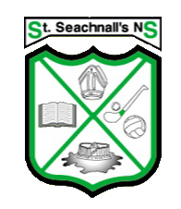

School Calendar 2021-2022

School re-opens: | Tuesday 31st August 2021
Halloween Mid-term Break: | School will be closed from Monday 25th October to Friday 29th October. Return to school Monday 1st November
Christmas Holidays; | School closes on Wednesday 22nd December at 12.30 and reopens on Thursday 6th January 2022
Spring Mid Term: | School Closed Monday 21st to Friday 25th February 2022.
St. Patrick’s Weekend | School closed 17th & 18th March 2022
Easter Holidays: | School closes on Friday 8th April at 12.30 and reopens on Monday 25th April 2022.
Confirmation | Date to be decided
May: | The school will be close on Monday 2nd May 2022.
First Holy Communion: | Date to be decided
June Bank Holiday: | The school will be closed on Friday 3rd & Monday 6th June.
Summer Holidays: | School Closes at 12.30 on Thursday 30th June 2022.

In the event of extensive or prolonged closures due to unforeseen circumstances this calendar may be subject to change.

Regards,
Ms. Ciara Whelan
Principal

