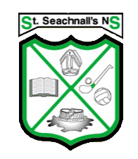

School Calendar 2023-2024

School re-opens: | Thursday 31st August 2023
Halloween Mid-term Break: | School will be closed from Monday 30th October to Friday 3rd November. Return to school Monday 6th November 2023
Christmas Holidays: | School closes on Friday 22nd December at 12.30 and reopens on Monday 8th January 2024
February Bank Holiday | School closed on Monday 5th February 2024
Spring Mid Term: | School Closed Thursday 15th & Friday 16th February 2024
St. Patrick’s Weekend: | School closed Monday 18th March
Easter Holidays: | School closes on Friday 22nd March at 12.30 and reopens on Monday 8th April 2024
May: | The school will be closed on Monday 6th to Friday 10th May 2024
June Bank Holiday: | The school will be closed on Monday 3rd June
Summer Holidays: | School Closes at 12.30 on Friday 28th June 2024

In the event of extensive or prolonged closures due to unforeseen circumstances this calendar may be subject to change.

Regards,
Ms. Ciara Whelan
Principal

