St Seachnall’s NS
Main Street,
Dunshaughlin,
Co. Meath.

Roll No. 17930Q

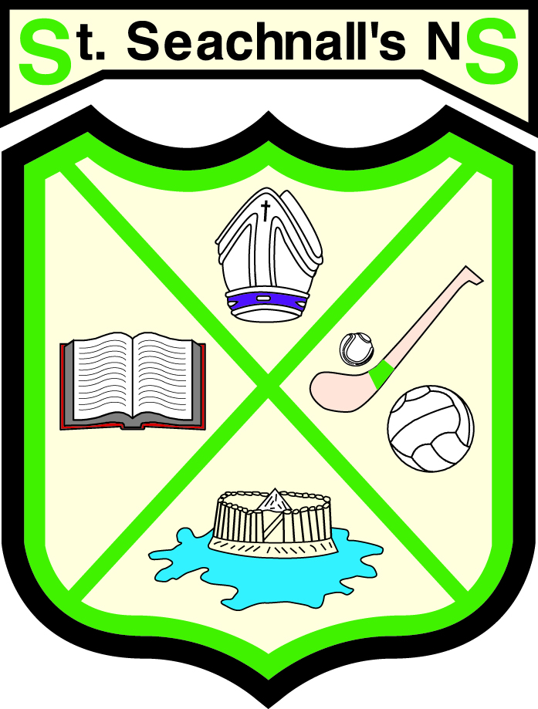

School Self Evaluation Report

June 2014

St Seachnall’s NS
School Self Evaluation Report
Introduction
A school self evaluation of teaching and learning in St Seachnall’s NS, Dunshaughlin was undertaken during May and June 2014. During the evaluation teaching and learning in numeracy was evaluated.
Parents were surveyed to get their views on their child(ren)’s progress and attitude to Mathematics and were asked to identify how the school could help their children with Mathematics.
The following sources of evidence were used to compile the findings of this report:
- Standardized test outcomes
- Pupils’ work – samples, copies.
- Class teachers’ observations
- The Learning Support team’s observations.
- Parental Questionnaires
- Pupil Questionnaires – third to sixth class.
This is a report on the findings of the evaluation.

The School Context.
Patron: Bishop Michael Smyth, Catholic Bishop of Meath
Chairperson: Rev. Joseph Clavin, PP
Principal: Jim Gilligan
Staff: 19 Mainstream class teachers, 6 Learning support/resource teachers, 2.5 SNAs and 2 part-time Classroom Assistants employed by the Board of Management.
Pupils: 515 pupils, boys and girls, from Junior Infants to Sixth Class
Website: www.stseachnalls.ie
School Growth: Our school community has grown substantially over the last decade, from 300 in 1999-2000 to the current level of 515.
Awards: We have 4 Green Flag Awards, Intel Mini Scientist Awards and Credit Union Quiz wins. In past two years the Girls’ team has won the Fingal and Meath GAA Leagues, the Boys have won the Fingal League. Girls have been Meath and North Leinster Soccer 5-a-side champions in both years.

Initiatives:
      - Four Green Flags for Litter & Waste, Energy, Water and Travel
      - Literacy Lift Off
      - Buddies System to pair senior pupils with pupils in infant classes
      - School Gaelic Football and Soccer Leagues
      - Participation in Fingal GAA Leagues and FAIS competitions
      - Gaelic Football and Hurling Coaching by Dunshaughlin and Drumree GAA Clubs. Strong link with Dunshaughlin GAA club
      - Intel Mini Scientists awards, 2013, 2014
      - Food Dudes Programme from September 2014
      - Application for Active Flag, 2014-15 School Year

The Findings of the Evaluation
Standardized Test Findings:
Sigma T tests in May 2012, 2013 and 2014 were evaluated

 | At or Below 2nd | 3rd – 16th | 17th – 50th | 51st – 84th | 85th – 98th | 99th
National Distribution | 2% | 14% | 34% | 34% | 14% | 2%
May 2014 | 0% | 8.9% | 29.1% | 35.9% | 22.7% | 3.4%
May 2013 | 0.3% | 6% | 32% | 31% | 25% | 5%
May 2012 | 0.2% | 6.5% | 24.8% | 35.3% | 28.3% | 4.9%

Preparation for Teaching:
Teachers’ planning is based on the Maths Curriculum and the school policy for Mathematics. Mental maths and estimation is encouraged across all the strands and there is a plan in place to focus on areas such as estimation, tables, fractions, shape etc for specific periods of time, usually a fortnight for each theme.

Teaching Approaches:
Talk and discussion is an integral part of Mathematics. Opportunities are provided for pupils to explain how they got the answer to a problem. There are agreed strategies outlined in the school plan for the teaching of addition, subtraction, multiplication and division. Mental mathematics and estimation is encouraged across all strands.

Management of Pupils
Classes use a variety of organisational styles – whole class work, group work, pair work and individual work. There is order and structure in the way activities are organised.

Assessment
Pupils’ work is regularly monitored and corrected by the class teacher. A variety of assessment modes are used in all classes to monitor progress. Assessment results are analysed and used for screening, diagnosis of learning difficulties or identifying aspects of maths needing re-teaching. Teachers differentiate their lessons to cater for children with different needs. Class teachers and Learning support teachers collaborate to ensure that supplementary teaching is available for children with learning difficulties. Team teaching and early intervention strategies are provided where resources permit.

Learning Environment
The school is a safe stimulating environment and classrooms and the building in general is organised, clean and well maintained. The school environment is used to provide opportunities for mathematical problem solving and creating an awareness of number, e.g. measuring, estimating.

Pupil’s engagement with learning
77% of pupils from fourth to sixth class reported that they like Maths, with the percentage higher in the lower classes than in the higher ones.

Parental Involvement
280 parents returned the survey. Of those who returned the survey 89 percent reported that their children liked Maths and 86 per cent felt their child was doing well at Maths. Twenty-eight per cent indicated that they didn’t get sufficient information about their children’s progress in Maths and efforts to address this are included in our school improvement plan for numeracy.

Summary of School Self Evaluation Findings
Our school has strengths in the following areas with regard to Numeracy:
- Standardised tests scores for numeracy attainment are significantly above the national norms
- Mental Maths is encouraged across the strands
- There is an agreed whole school policy on strategies for teaching various Maths topics.
- Teachers’ planning is based on the Maths curriculum and the school Maths plan.
- Talk & Discussion and opportunities for pupils to explain answers are part of Maths lessons.
- There is an agreed approach to numeral formation and presentation of written work.
- The school has a fairly good supply of Maths resources.
- Results of assessments are used to inform teacher planning.

The following Areas are prioritized for improvement with regard to Numeracy:
- Strategies to support pupils’ problem solving to be agreed at whole school level.
- Focus on the language of Mathematics
- Focus on estimation
- Emphasis on presentation of Mathematical work. Agreed policy be amended:
- No Rough Work Column
- Two or four sections per page, all calculation to be shown within the section
- Must display units in use, e.g. cm, hrs, € etc.
- Focus on a topic for two weeks to be integrated into the strands being covered during that time, e.g. estimation, tables, fractions, shape.
- Procedure to be devised to provide more information to parents on their children’s progress and approaches used in the school to teach the various topics.

The following Legislative and regulatory requirements need to be reviewed:
- Data Protection Policy, to be developed
- Revised RSE Policy drafted by staff sub-committee. Draft to be considered by sub committee of teachers, parents and Board of Management representatives with target of Board of Management ratification by January 2015.

